Product Inventory Management System

Project Overview
The Product Inventory Management System is a backend-based web application developed using Node.js, Express.js, and MongoDB. The system is designed to manage product inventory efficiently by providing secure RESTful API services. It allows users to register, log in, and securely access system features using JWT (JSON Web Token) authentication.
The application focuses on providing a simple and efficient way to manage product records. Users can perform CRUD operations (Create, Read, Update, and Delete) on product data. Through the system, users can add new products, check the available inventory, modify product information such as price, name, or quantity, and remove products when necessary.
To improve security and privacy, the system ensures that each user can access only their own product data. The backend also includes proper input validation, error handling, and structured API responses to improve reliability and maintain system stability.

Key Objectives
• Implement secure user authentication using JWT tokens.
• Develop RESTful APIs to manage product inventory efficiently.
• Allow users to add, update, view, and delete products easily.
• Maintain data security and user privacy by restricting access to user-specific data.
• Improve system performance with proper validation and error handling mechanisms.
• Build a scalable and maintainable backend architecture using modern web technologies.

Target Users:
• Small business owners managing product stock and inventory records.
• Freelancers or sellers tracking items or services in a structured way.
• Developers learning backend API development and authentication workflows.
• Students working on backend or full-stack development projects.
• Anyone needing a secure and simple backend system for managing product data.

Project Instructions
• Create the backend project folder and initialize the Node.js project using npm.
• Configure the server using Express.js to handle API requests.
• Set up the MongoDB database connection using Mongoose.
• Implement user authentication APIs such as registration and login using JWT.
• Develop product management APIs that support CRUD operations (Create, Read, Update, Delete).
• Test all APIs using Thunder Client extension in Visual Studio Code to verify functionality.

Pre-Requisites

Software Requirements
Software | Purpose
Node.js | JavaScript runtime environment for building the backend server
MongoDB | NoSQL database used to store application data
npm | Package manager used to install project dependencies
VS Code | Development environment for writing and managing code

Knowledge Requirements
• Basic understanding of JavaScript ES6 concepts.
• Knowledge of Node.js and Express.js for building REST APIs.
• Understanding of MongoDB database and Mongoose ODM.
• Basic knowledge of JWT authentication and authorization.
• Understanding of middleware architecture in Express.js.

Project Thumbnail
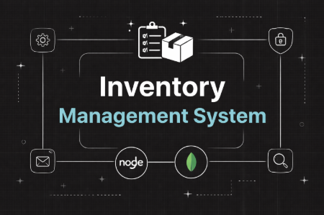

PROJECT ARCHITECTURE

High-level architecture diagram illustrating the three-tier backend structure.
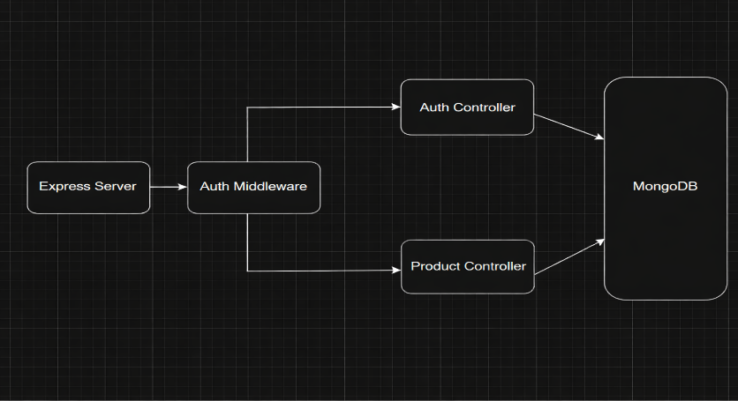
Node.js + Express Backend
• RESTful API architecture
• JWT authentication middleware
• MVC pattern (Models, Controllers, Routes)
• Input validation and error handling
MongoDB Database
• Document-based NoSQL storage
• Mongoose ODM for schema modeling
• Two collections: Users and Contacts
• Indexed fields for optimized queries

TECHNICAL ARCHITECTURE

Backend Architecture (Node.js + Express)
• Controllers: Handle authentication and product logic
• Models: Define database schema
• Routes: API endpoints for authentication and products
• Middleware: JWT verification and error handling
• Configuration: Environment variables and database connection

Database Architecture (MongoDB)
Users Collection:
• _id
• name
• email
• password (hashed)
• timestamps
Products Collection:
• _id
• userId (reference to user)
• name
• price
• quantity
• description
• timestamps
Relationship: One User → Many Products
Indexes:
• email (unique)
• userId
• product name
ER Diagram
ER diagram showing User → Product relationship:
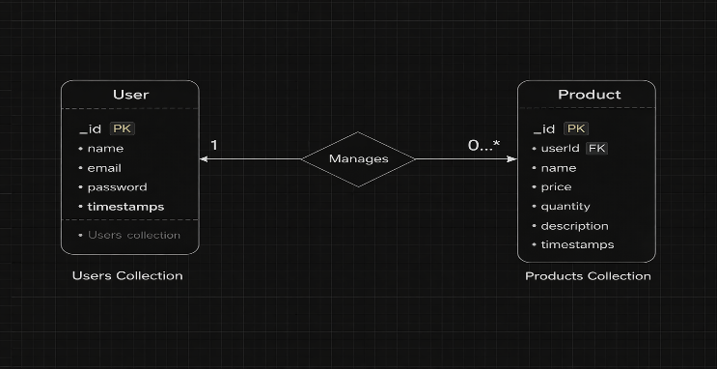

Features:

Core Features
S.No | Feature | Description
1 | User Authentication | JWT-based register and login system
2 | Product CRUD | Add, view, update and delete products
3 | Private Data Access | Users access only their own products
4 | Product Search | Search products by name
5 | Secure API | Middleware protected routes

Roles and Responsibilities

User
• User Registration: Users can create an account by providing basic details such as name, email address, and password.
• User Login: Registered users can log in to the system using their valid email and password credentials.
• Add Product: Users can add new products to their inventory by entering details such as product name, price, quantity, and description.
• Update Product: Users are allowed to modify existing product information when there are changes in price, quantity, or other details.
• Delete Product: Users can remove products from the inventory if the item is no longer available or required.
• Search Product: Users can easily search for specific products using keywords or product names within their inventory list.

User Flow
- The user sends a registration or login request to the backend server.
- After successful authentication, the backend generates a JWT (JSON Web Token) for the user.
- The user includes this JWT token in the Authorization header while making API requests.
- The authentication middleware verifies the token to confirm the user's identity and access permission.
- Once the token is verified, the controller processes the request and performs the required CRUD operation.
- The MongoDB database stores or retrieves product data depending on the request type.
- Finally, the API returns a structured response to the client indicating success or failure.

- Project Setup and Configuration
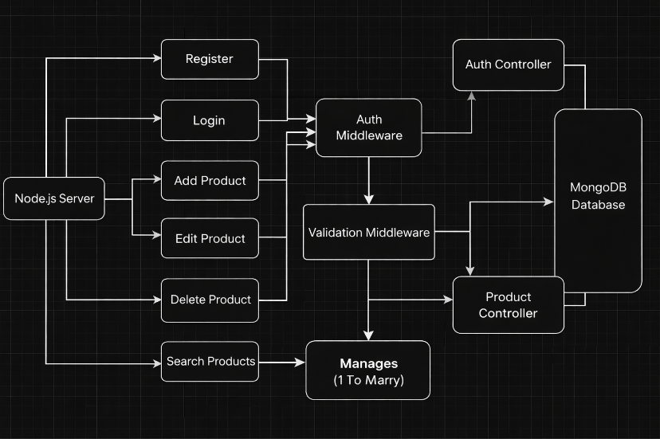
Folder Structure

server/
│
├── node_modules/
├── src/
│ ├── controllers/
│ ├── db/
│ ├── middlewares/
│ ├── models/
│ ├── routes/
│ └── server.js
│
├── .env
├── .gitignore
├── package-lock.json
└── package.json

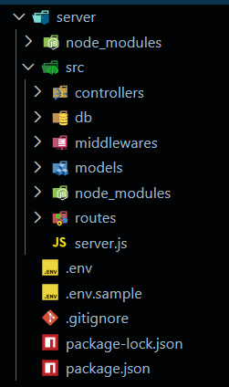
Initialize Node.js Project:
Open terminal inside the server folder and run:
npm init -y
This creates the package.json file which manages project dependencies.

Install Required Packages:
Install backend dependencies:
npm install express mongoose cors dotenv jsonwebtoken bcryptjs

Package Purpose:
- express → Backend framework
- mongoose → MongoDB connection
- cors → Cross-origin requests
- dotenv → Environment variables

- jsonwebtoken → Authentication
- bcryptjs → Password hashing
- PORT=5000
MONGO_URI=your_mongodb_connection_string
JWT_SECRET=your_secret_key

Backend Development

Setup Express Server:
Inside src/server.js, create the basic Express server.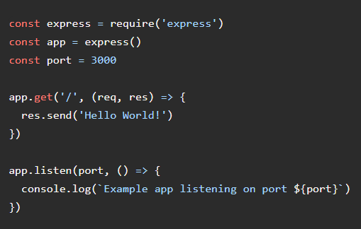

Authentication Controller (Auth Controller)
The Authentication Controller handles all user authentication processes in the application. It manages the user registration and login system and ensures that only authenticated users can access protected resources. The controller uses JSON Web Tokens (JWT) to provide secure access to the system.

Responsibilities
• Handle new user registration in the application.
• Perform validation of user input data such as email and password.
• Securely encrypt passwords using bcrypt before storing them in the database.
• Verify user credentials during the login process.
• Generate JWT tokens for authenticated users to access protected APIs.
• Return proper success messages or error responses to the client.

Key Functionalities
User Registration:
This feature allows a new user to create an account by providing required details. The system checks whether the email already exists and securely stores the encrypted password in the database.
User Login:
This feature authenticates the user by verifying their email and password. After successful
product.controller.js
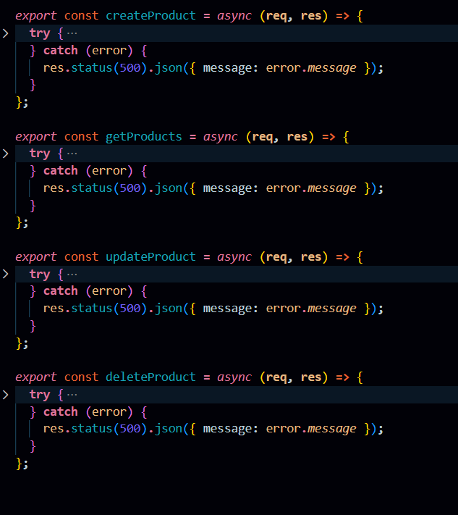

Product Controller
The Product Controller handles all product inventory operations and contains the business logic for managing products linked to individual users.

Responsibilities:
- Add new products to inventory
- Fetch products belonging to logged-in users
- Update product details like price, quantity, or description
- Delete products securely
- Perform product search functionality

Main Functionalities:
- Create Product: Adds a new product with a reference to the authenticated user.
- Get Products: Retrieves only the products created by the logged-in user.
- Update Product: Modifies product details while verifying ownership.
- Delete Product: Removes a product safely from the database.
- Search Product: Allows filtering products based on name.

Create Middleware
Inside: src/middlewares/

Create:auth.middleware.js
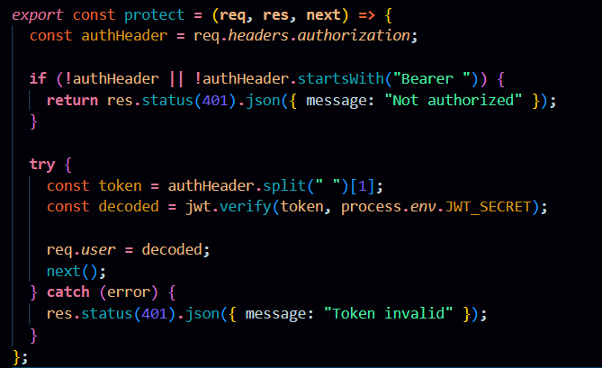

Auth Middleware (protect)
The Auth Middleware secures protected routes by verifying the JSON Web Token (JWT) sent in the request header. It checks for a valid Authorization header starting with "Bearer " and validates the token using the secret key. If the token is valid, the decoded user information is attached to req.user and the request proceeds to the next controller. If the token is missing or invalid, the middleware returns a 401 Unauthorized response, preventing access to private APIs.
Create Routes
Inside: src/routes/

Create:

auth.routes.js

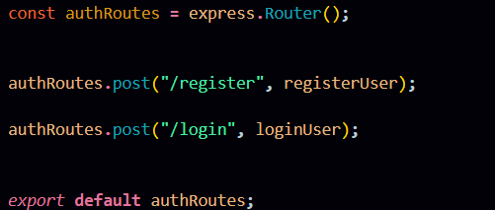

Auth Routes:
Auth routes handle user authentication by providing endpoints for registration and login. These routes connect incoming requests to the Auth Controller to create new users and generate JWT tokens product.routes.js

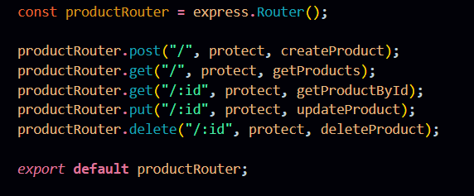

Product Routes
Product Routes handle all operations related to product inventory within the system. These routes allow users to create, view, update, and delete product information stored in the database.
To maintain security, all product-related routes are protected with authentication middleware. This ensures that only authenticated users can access and manage their own product records.

Responsibilities of Product Routes
• Add new products to the inventory system.
• Retrieve product data from the database.
• Modify product details such as name, price, or quantity.
• Remove products from the inventory when they are no longer needed.
• Ensure that product operations are performed only by authorized users.

Database Configuration and Setup
- Create MongoDB Atlas cluster
- Add connection string to .env
- Connect DB before API testing.
Database Connection:
Create a file inside: src/db/db.js
Purpose: Connect backend to MongoDB using mongoose.
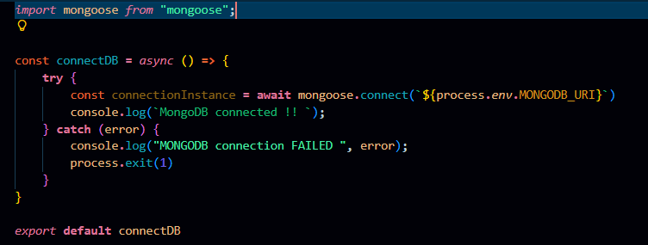

The connectDB function establishes a connection between the application and MongoDB using Mongoose and environment-based configuration. It ensures the server starts only after a successful database connection and logs an error message if the connection fails.

Create Models:
Inside src/models/ create:
- User.js
- Product.js

User Model:
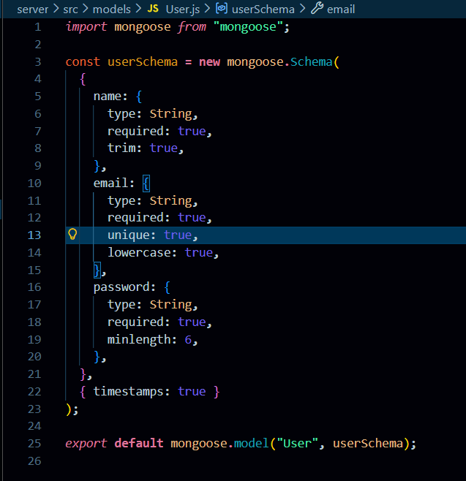
User Schema:
The User schema defines the structure for storing user details such as name, email, and hashed password in the database. It supports secure authentication and maintains timestamps for record tracking.
Product Model:

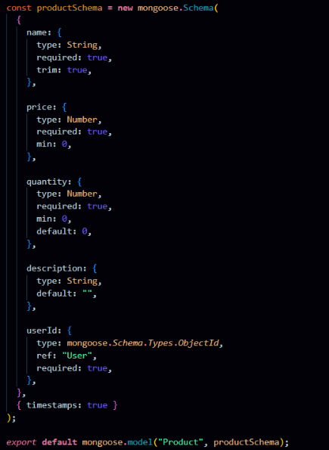
Product Schema:
The Product schema represents inventory items and includes fields like name, price, quantity, description, and a userId reference. It ensures each product is linked to its owner, enabling private data access and management.
Project Execution

Execution Steps
- Open terminal in server folder.
- Make sure you have a start script in the package.js file.
- Run:
npm start

- Console should display:
Server running on PORT
Database Connected

API Testing :
Use Thunder Client to test APIs:
Test APIs:
Register User:
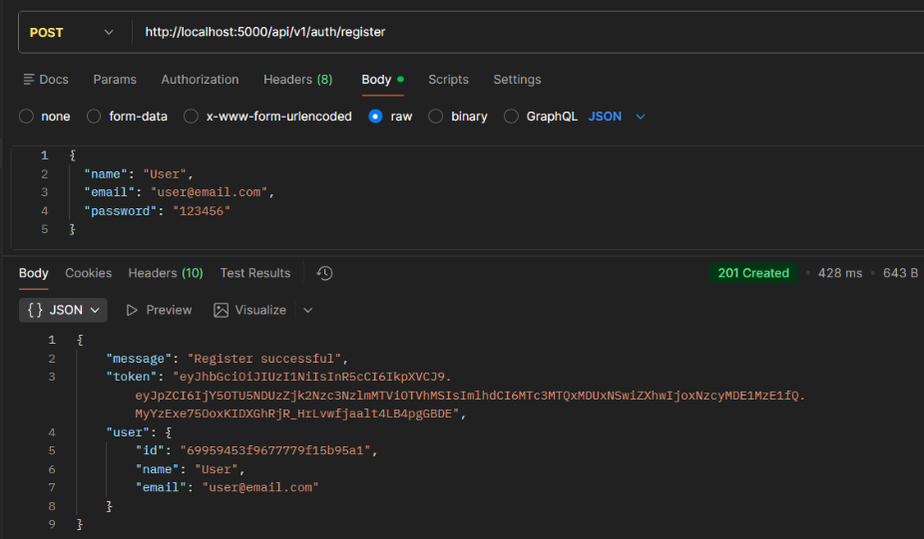
Register:
The register functionality allows new users to create an account by submitting their details, which are validated and securely stored with a hashed password. It ensures unique user creation before granting access to the system.

API Testing :
Use Thunder Client to test APIs:
Test APIs:
Register User:
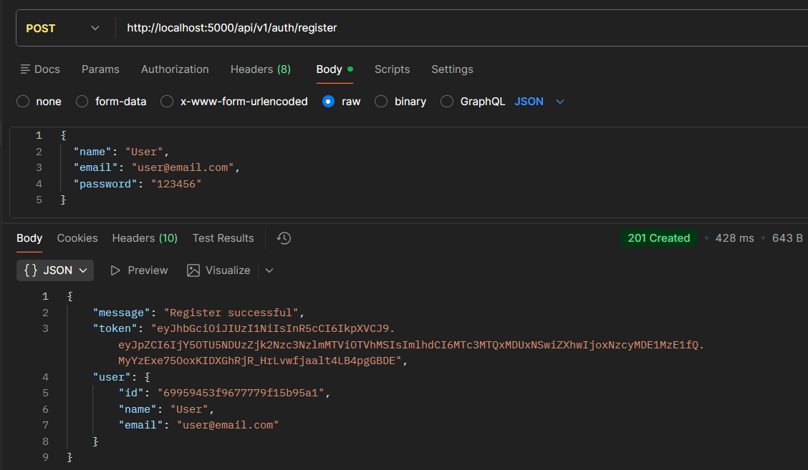
Register:
The register functionality allows new users to create an account by submitting their details, which are validated and securely stored with a hashed password. It ensures unique user creation before granting access to the system.
Login User
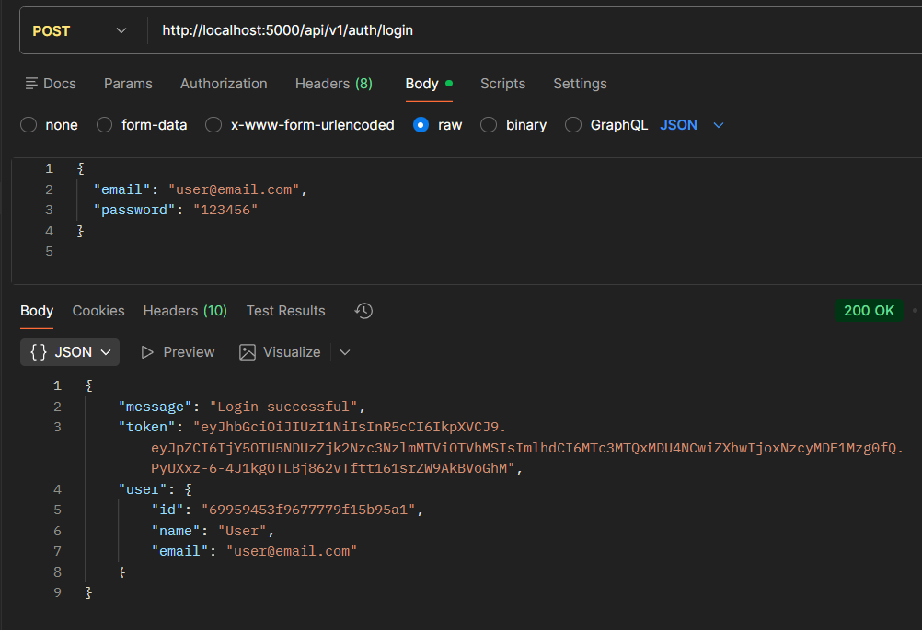
Login:
The login functionality verifies user credentials and generates a JWT token upon successful authentication. This token is used to access protected routes securely.
Create Product
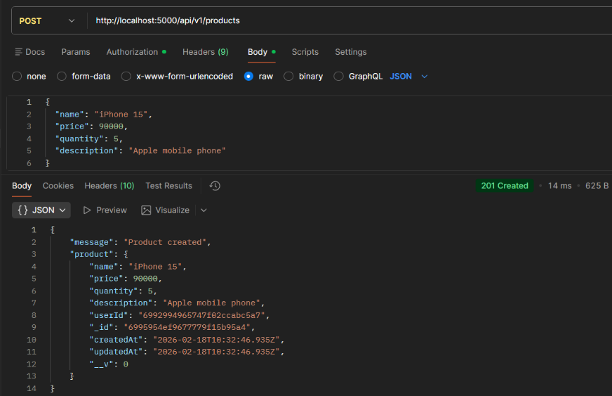
Create Product:
Allows an authenticated user to add a new product to their inventory by submitting product details. The product is saved with the user’s ID to maintain ownership.
Get all Products
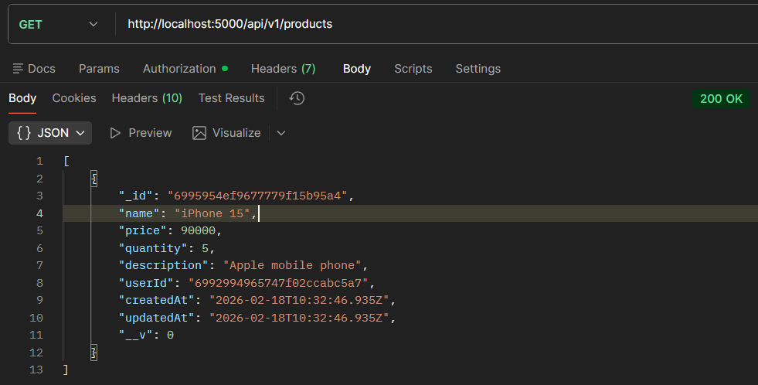
Get all Products:
Fetches all products that belong to the logged-in user. It ensures users can view only their own inventory data.

Update Product
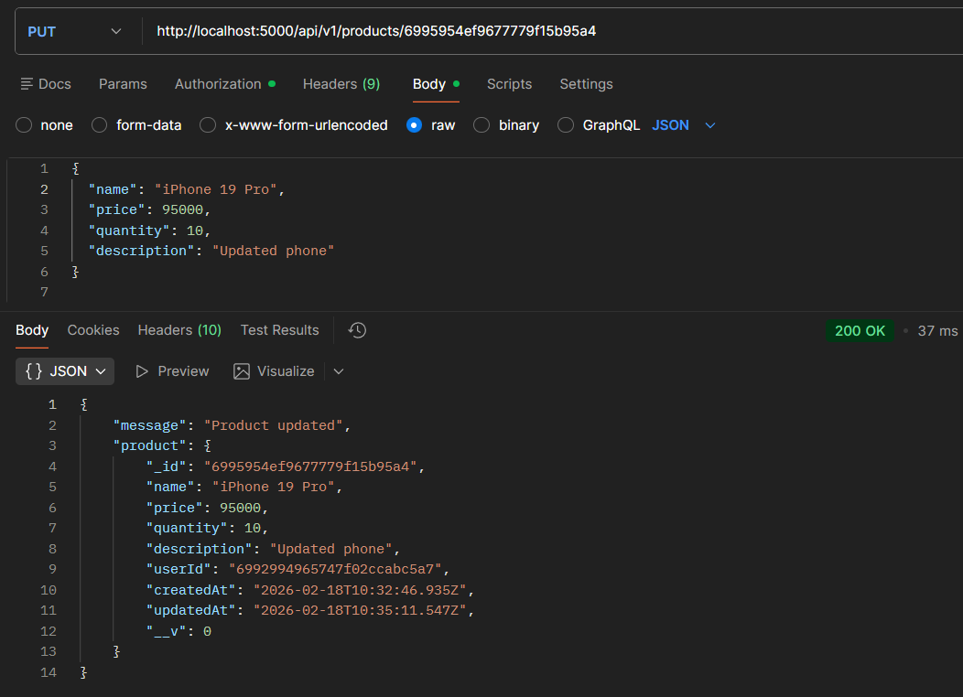

Update Product:
Enables users to modify existing product details such as name, price, or quantity. The system verifies ownership before allowing any updates.

Delete Product
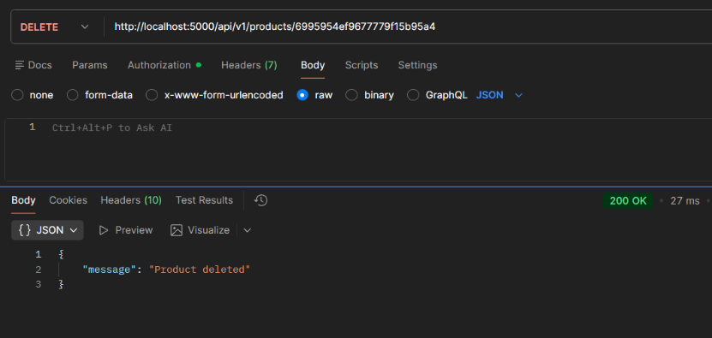
Delete Product:
Allows users to permanently remove a product from their inventory. The operation is protected to ensure only the product owner can delete it.

